I am the developer of this project. The system which I developed are trying visualized below as screenshot.

**Home**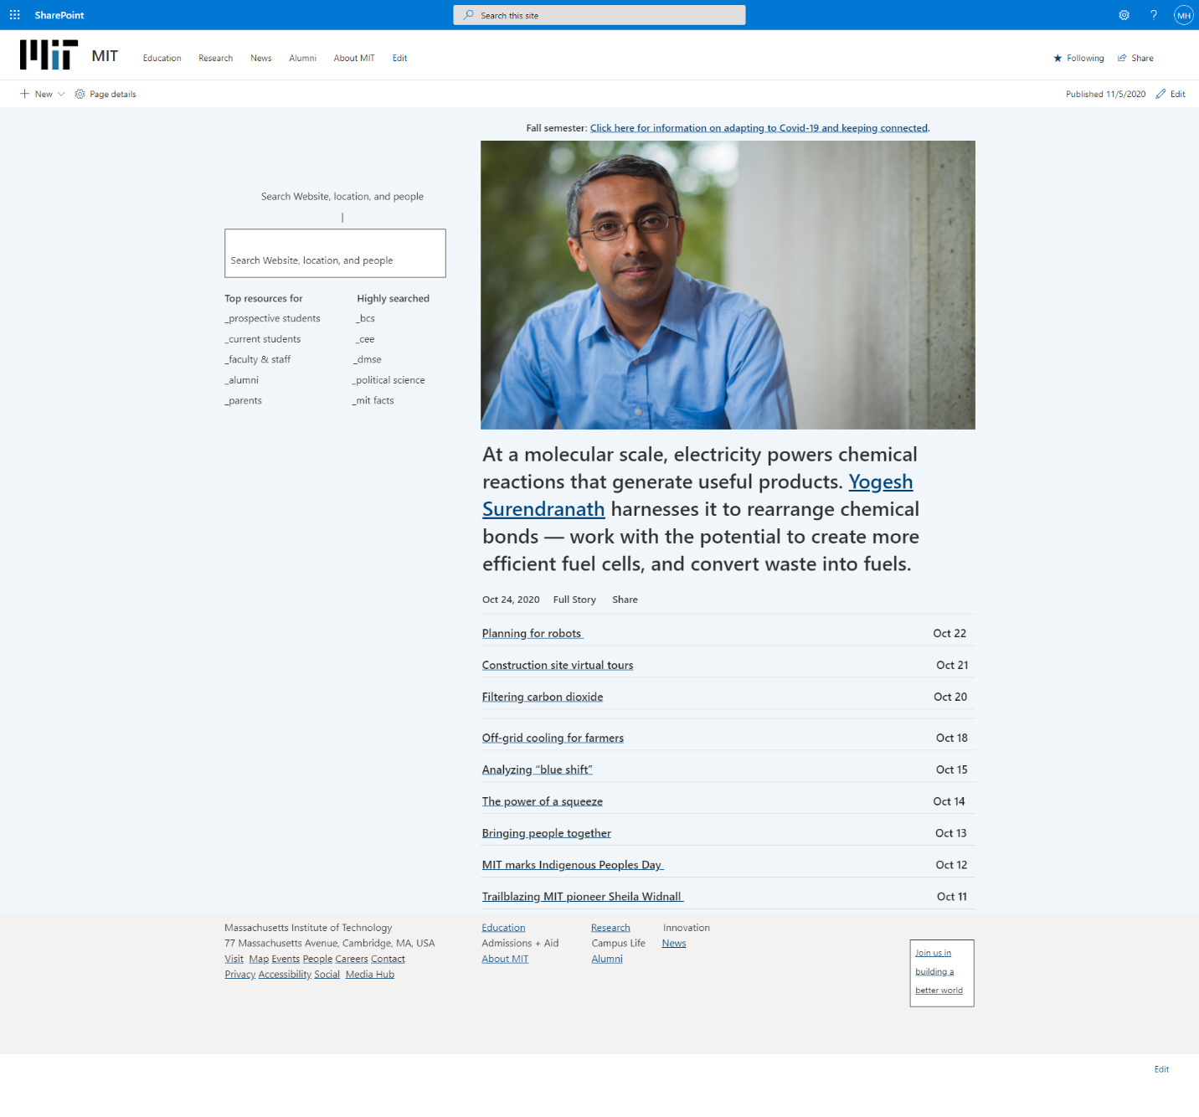

Screenshot 1: Home

### **Education as Course Offered**

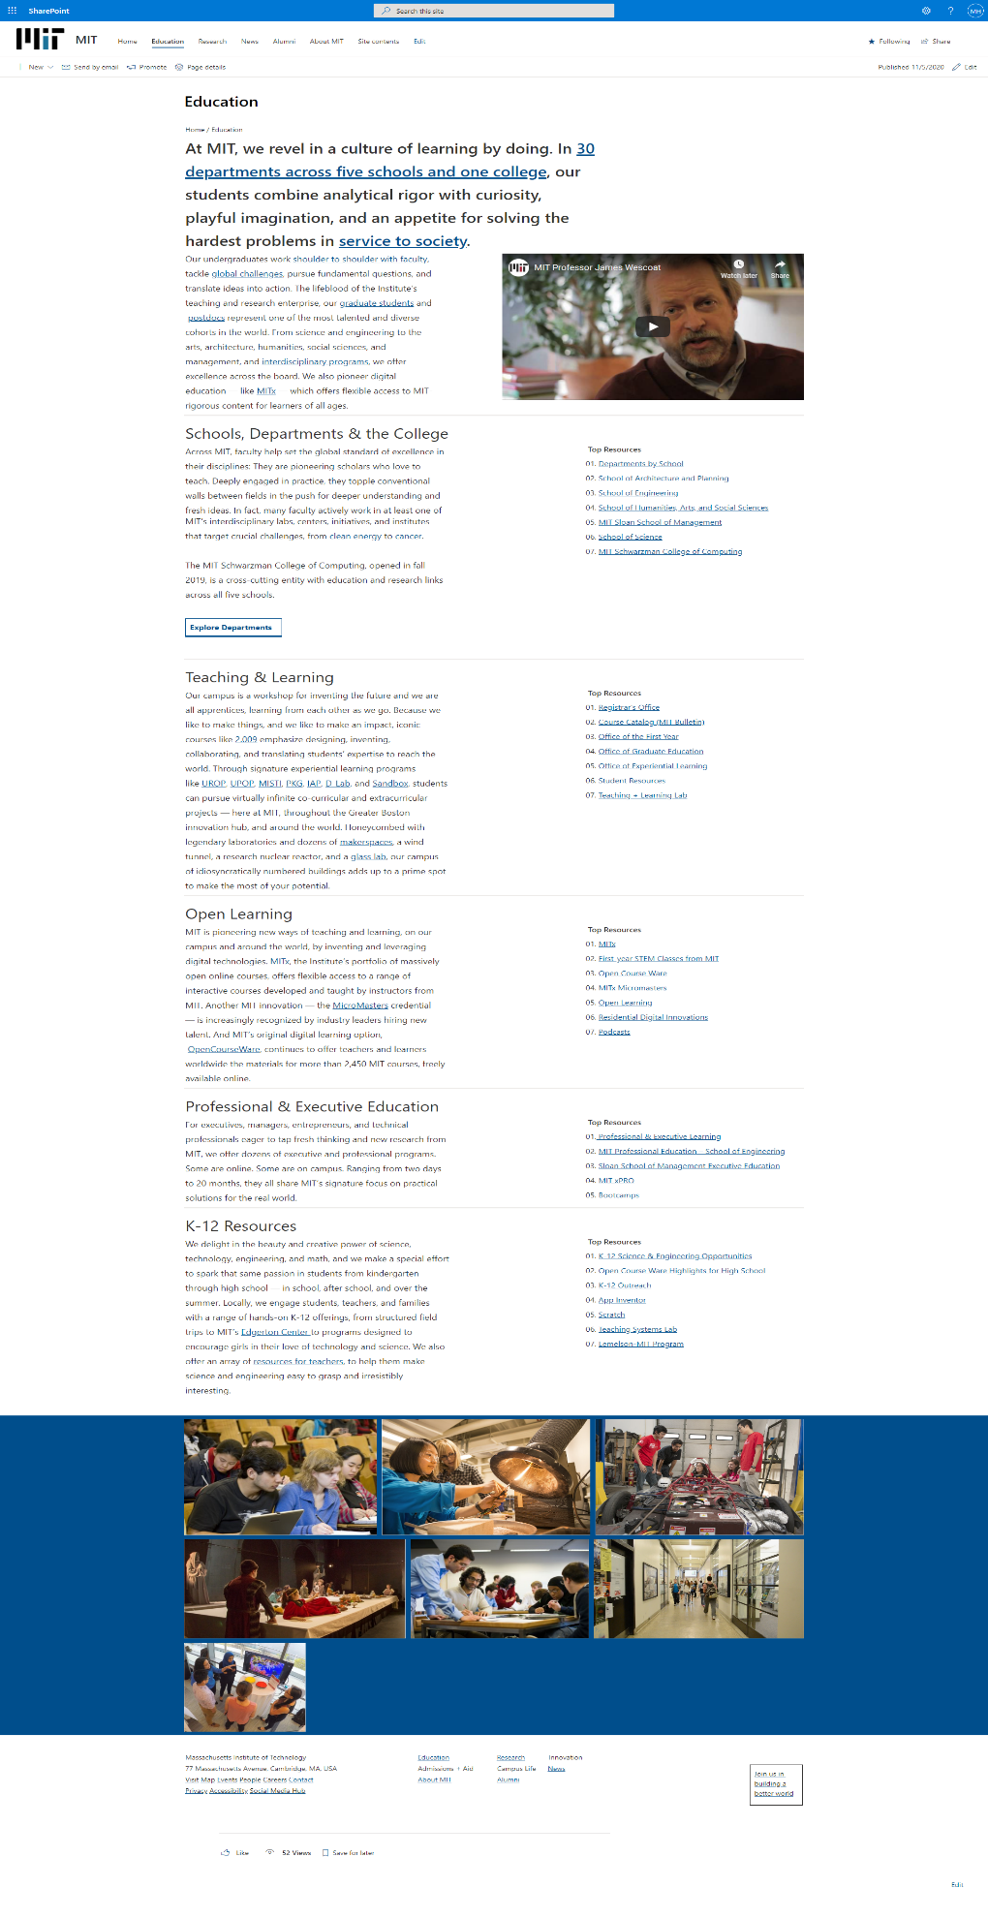

Screenshot 2: Education

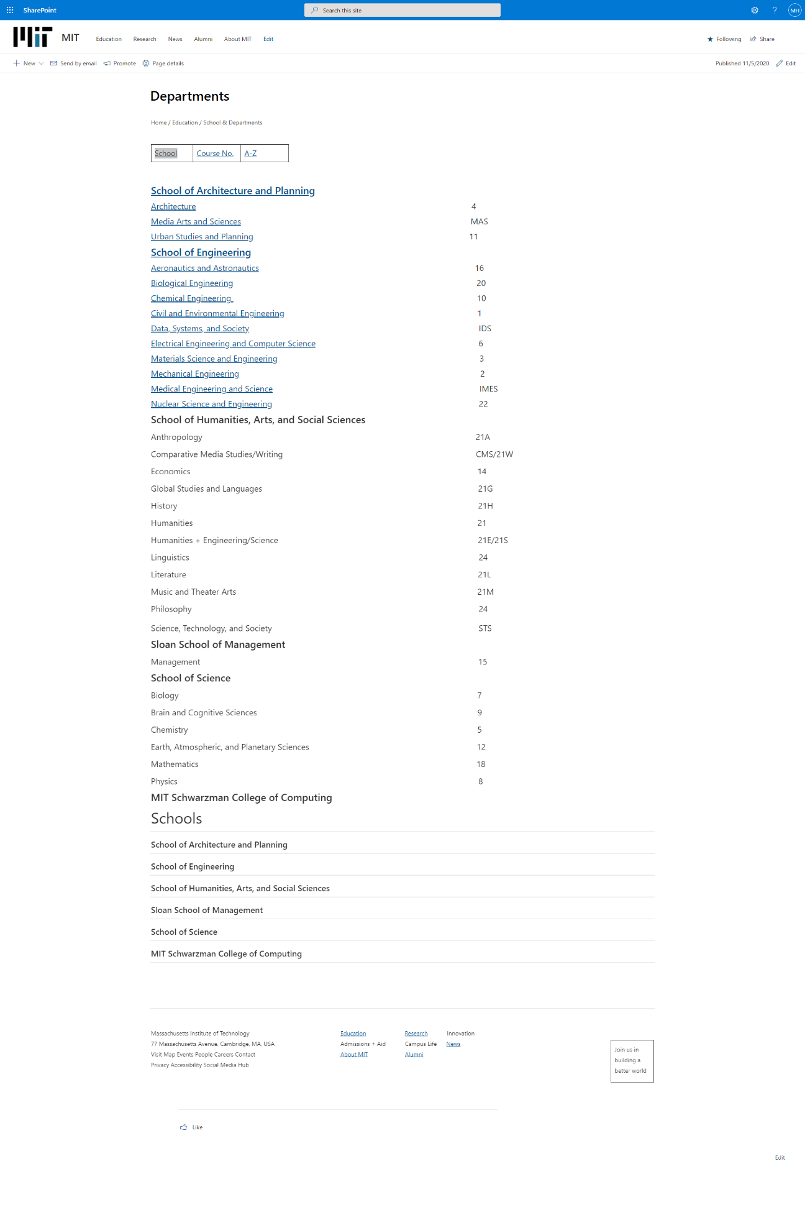

Screenshot 3: School Courses

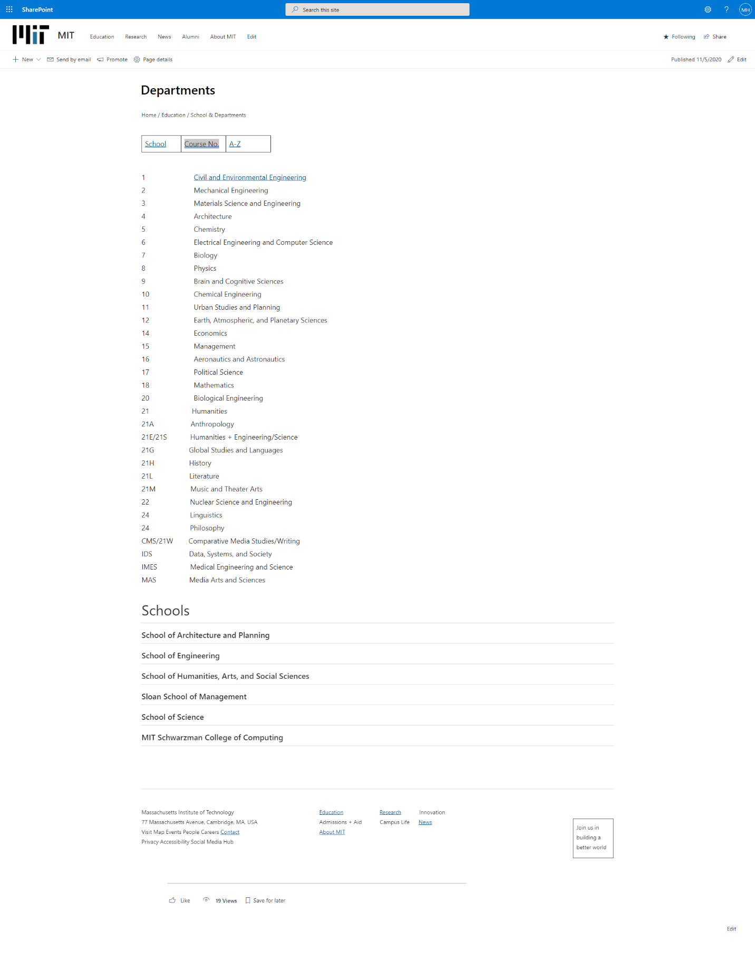Screenshot 4: Courses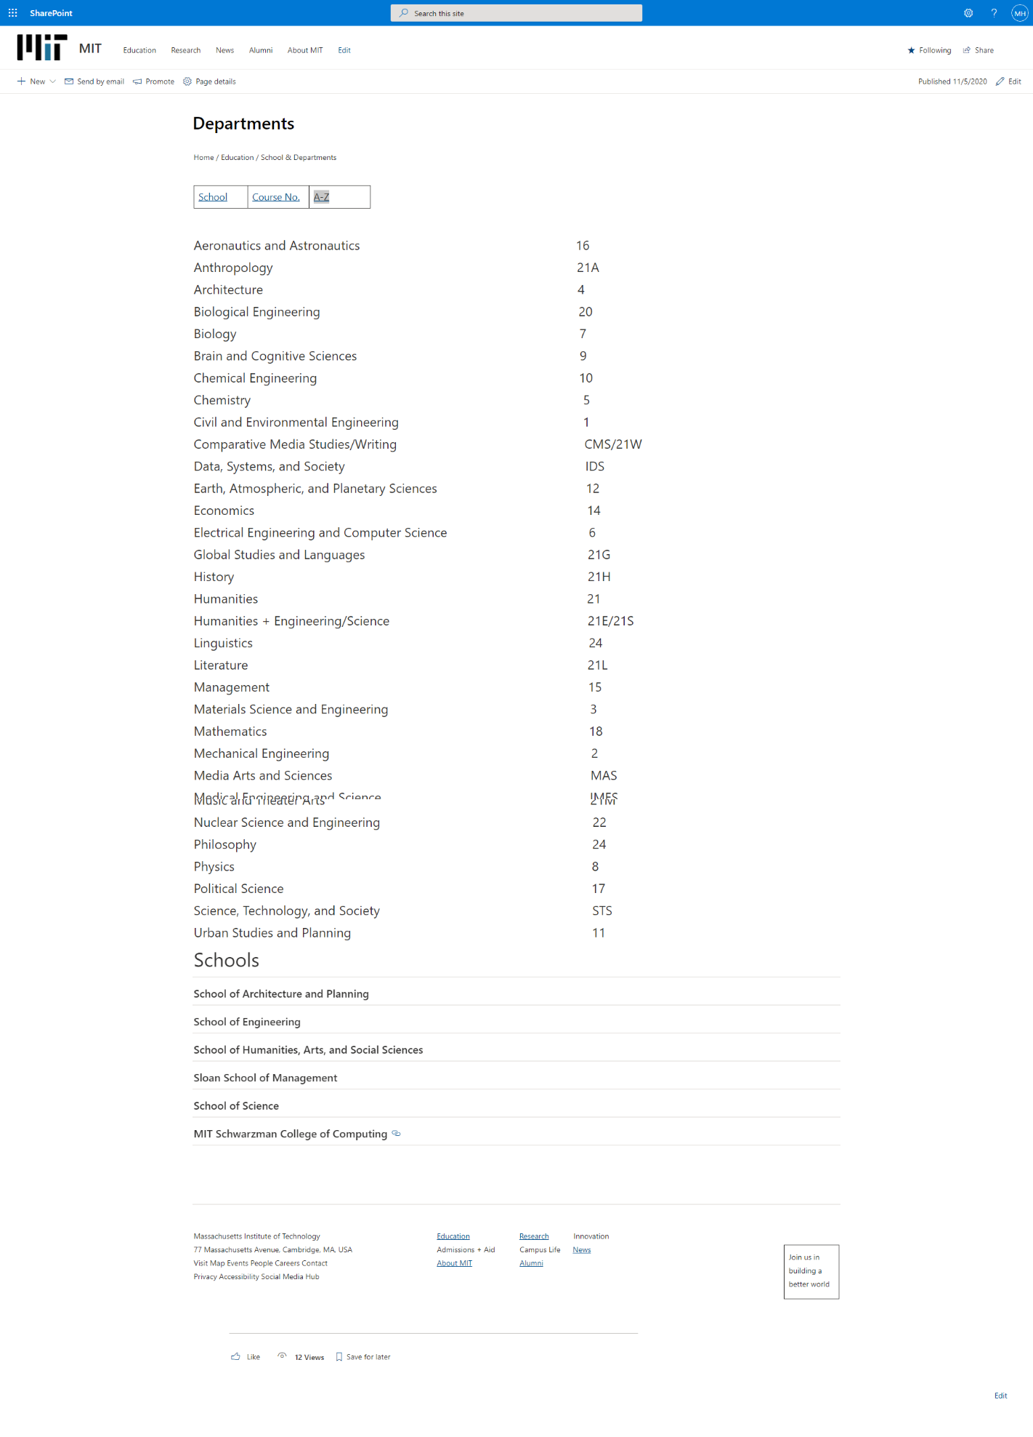Screenshot 5: All courses

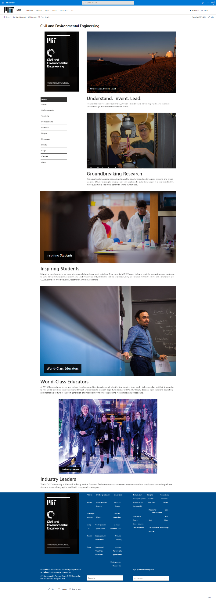

Screenshot 6: Showing Civil and Environmental Engineering Course

### **Research**

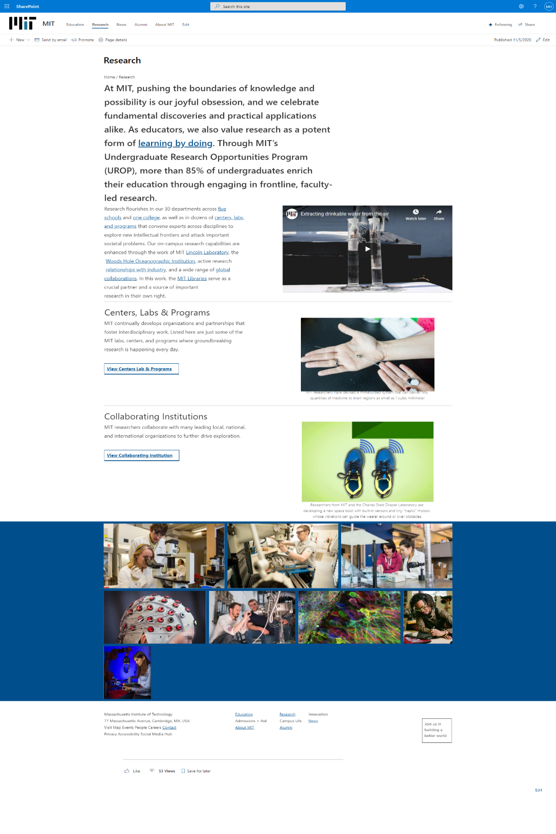

Screenshot 7: Research Page

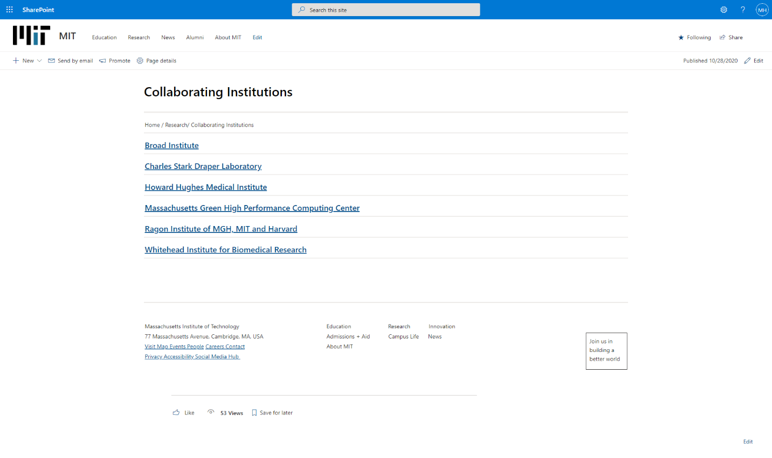

Screenshot 8: Showing Collaborating Institution

### **News**

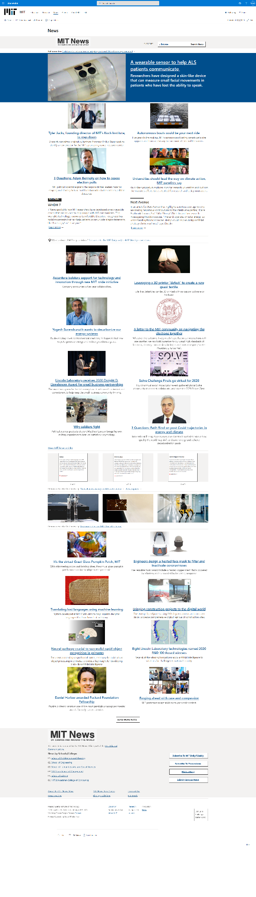

Screenshot 9: News Page

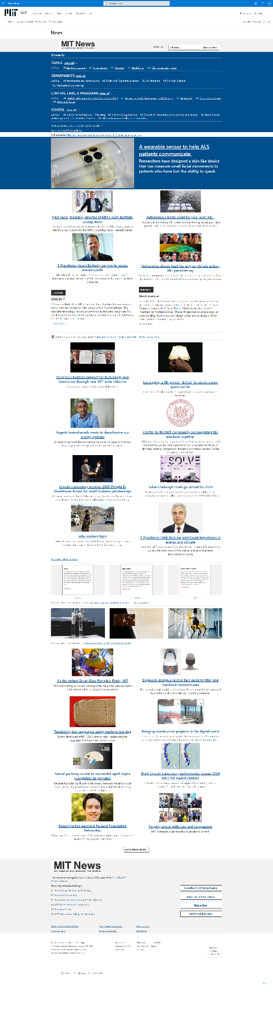

Screenshot 10: News Page with dropdown menu

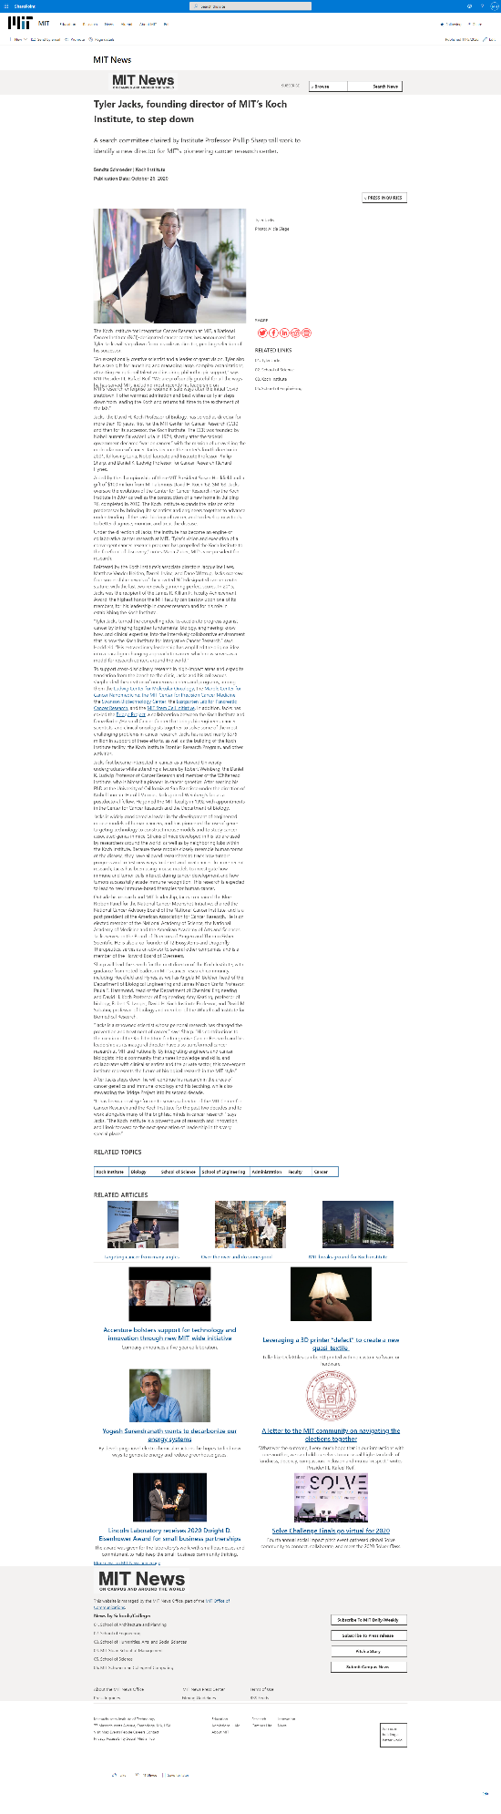

Screenshot 11: A full News

### **Success Stories of Previous Students**

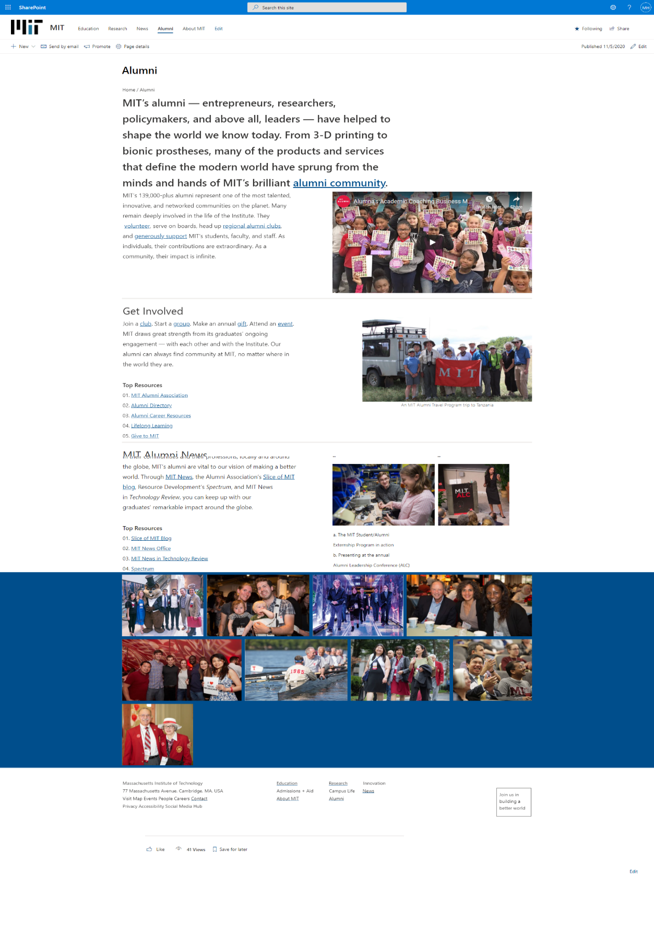

Screenshot 12: Pervious Students Page as Alumni

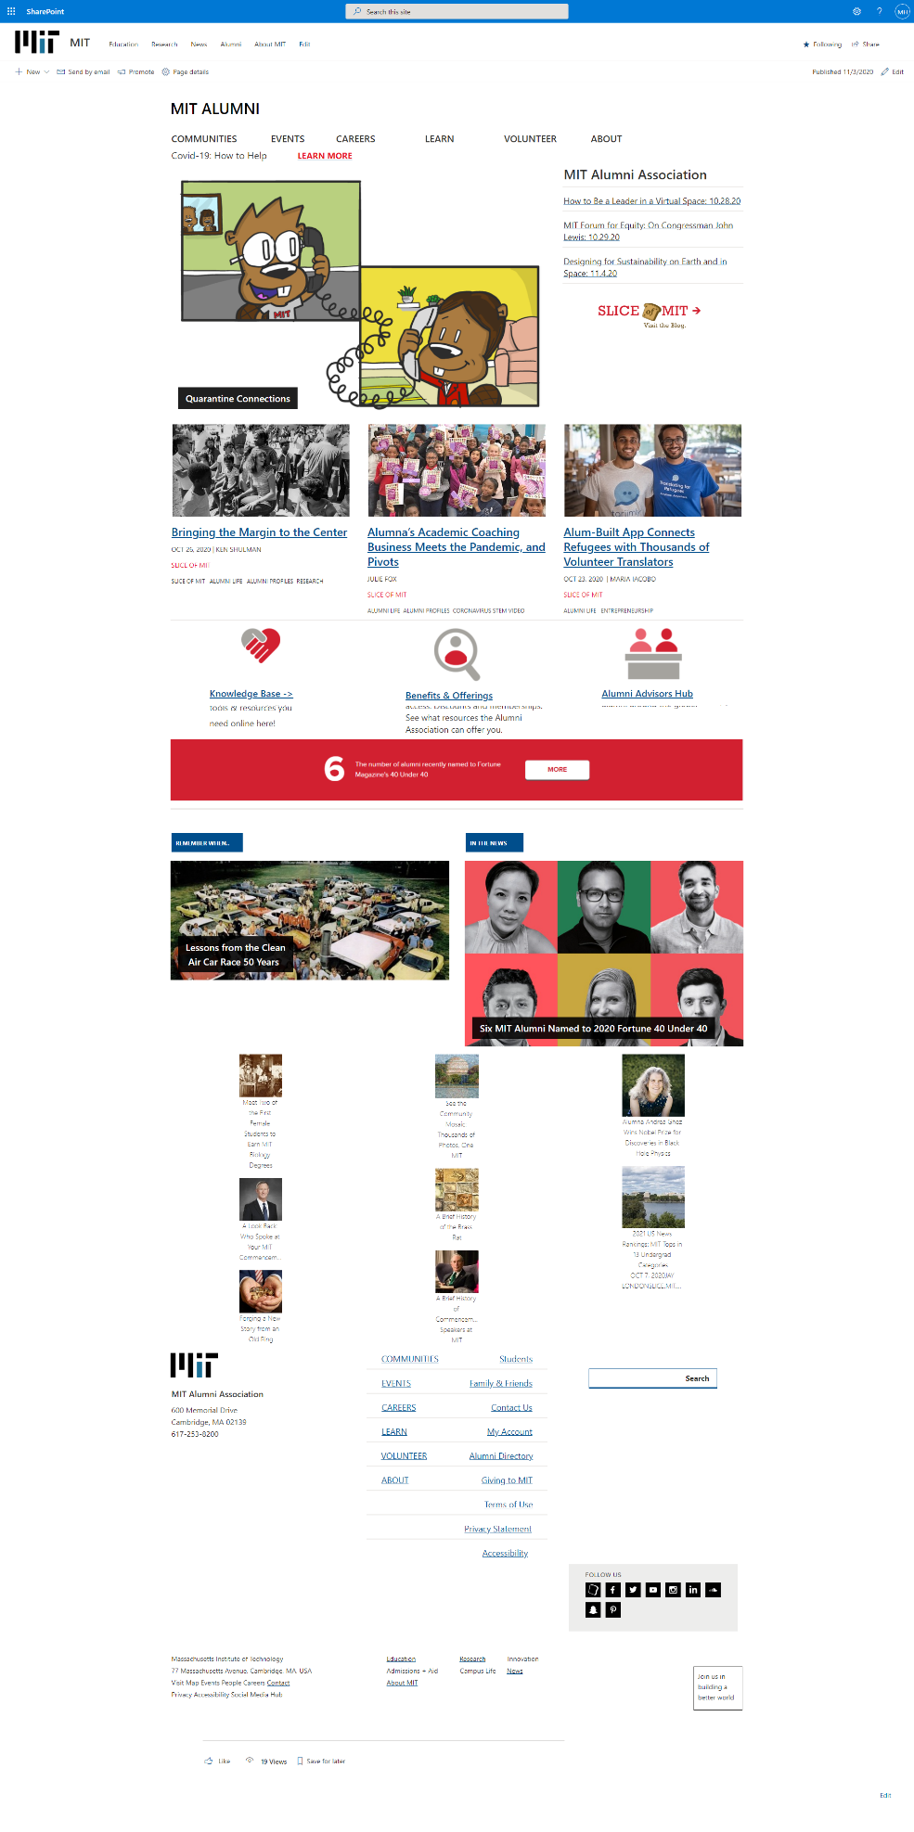

Screenshot 13: Success Stories of MIT Alumni

### **About MIT**

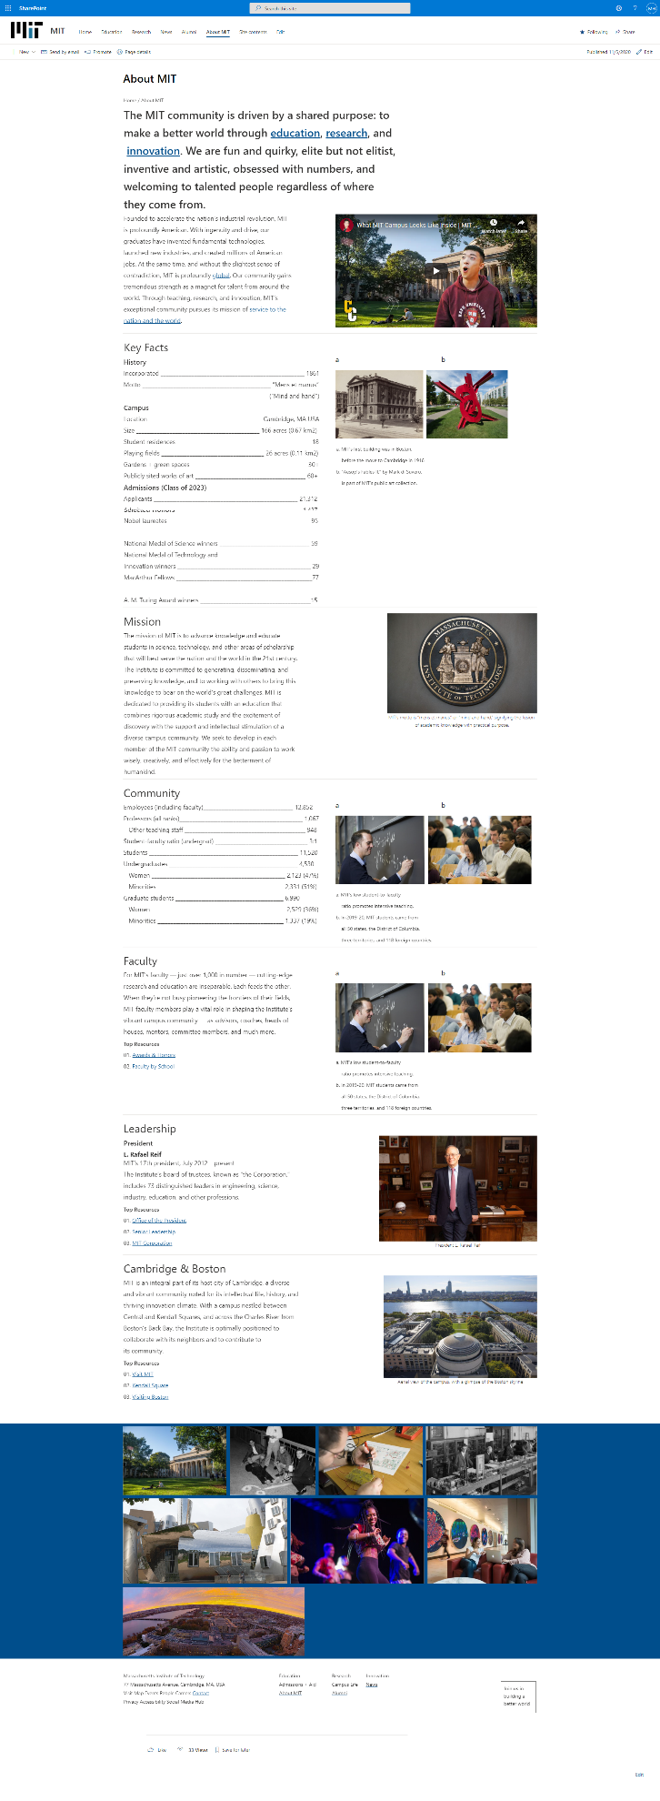

Screenshot 14: About MIT Page

### **Contact Page**

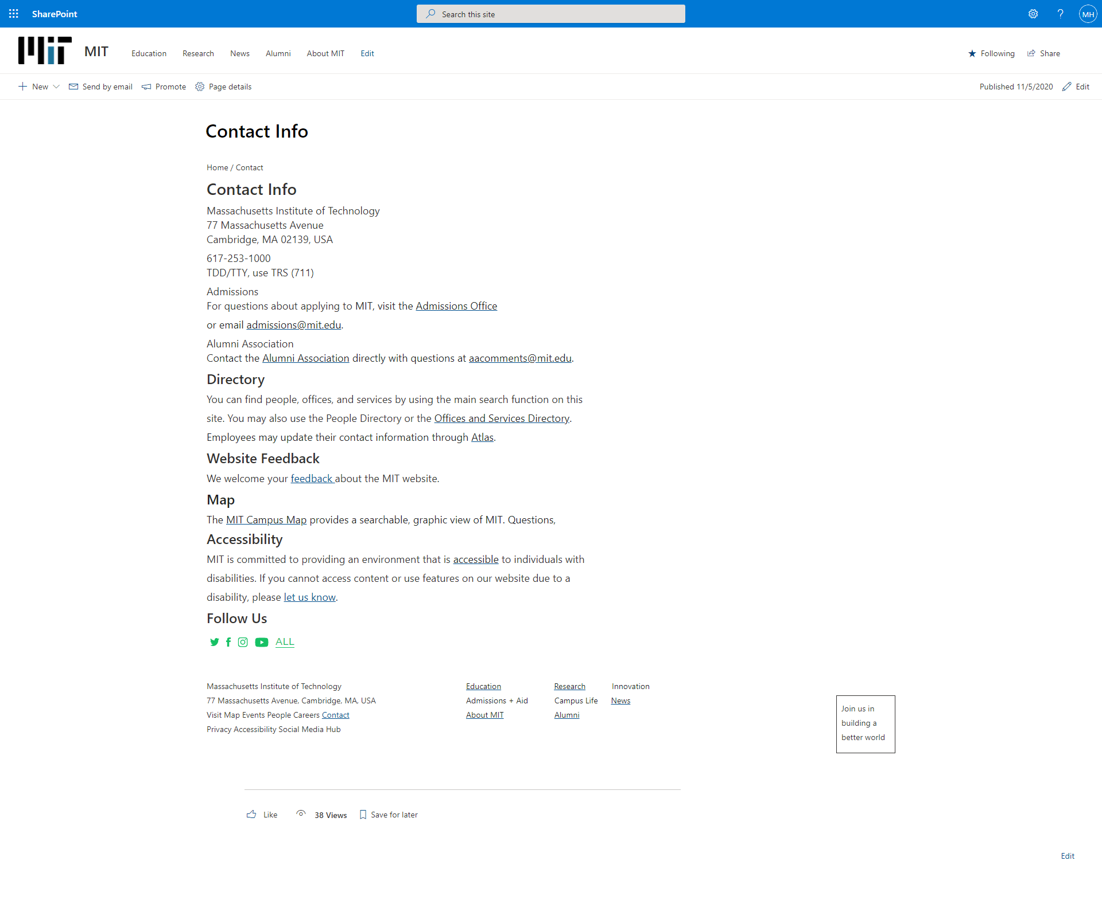

Screenshot 15: Contact Page

### **Enquires Form**

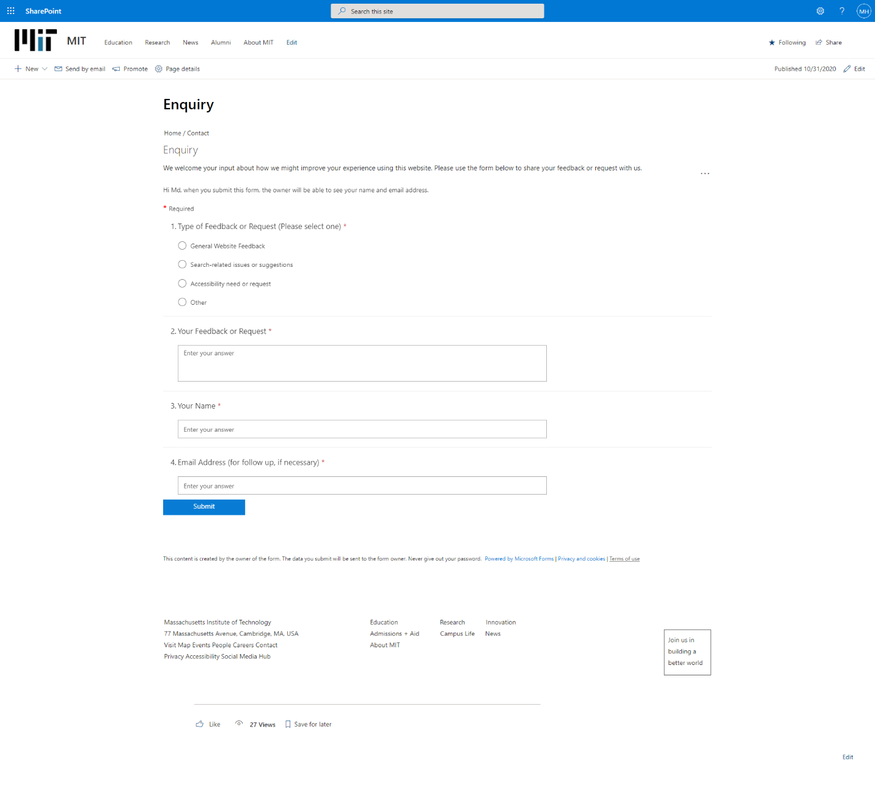

Screenshot 16: Enquires Form of MIT

### **Work of Database**

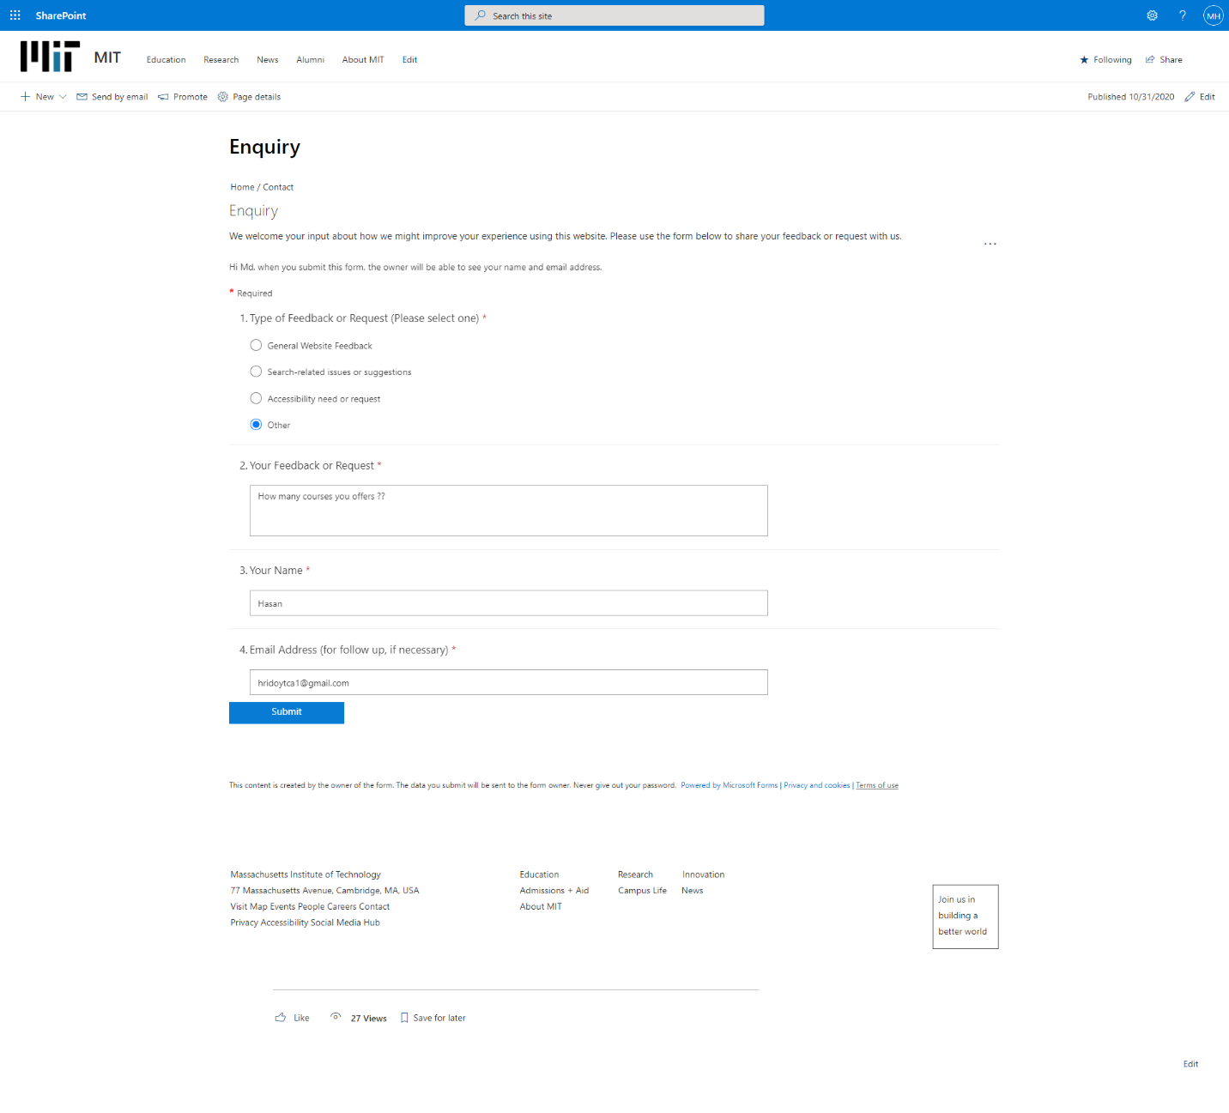

Screenshot 17: Entry for database

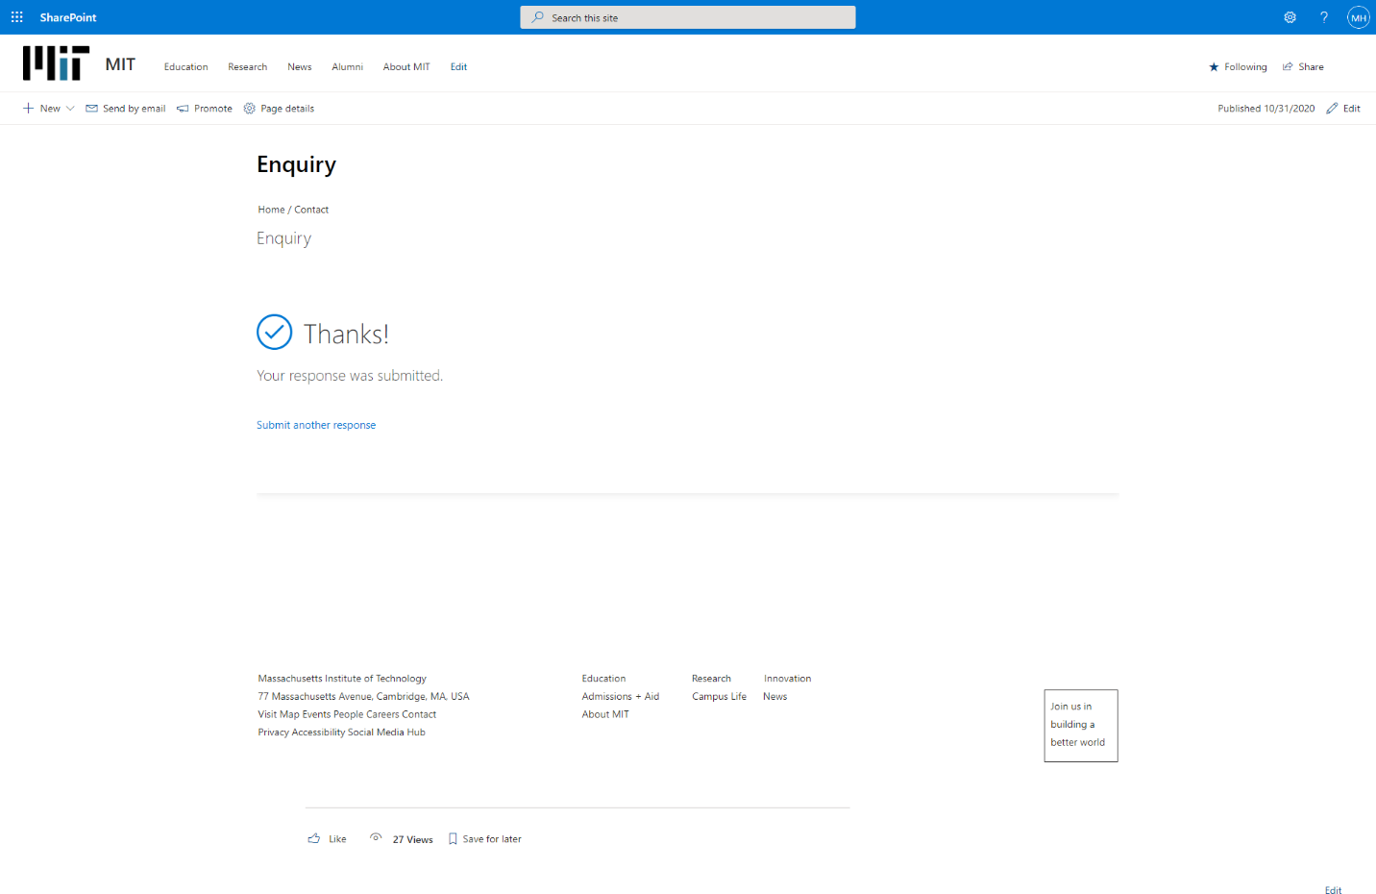Screenshot 18: Entry Input successfully.

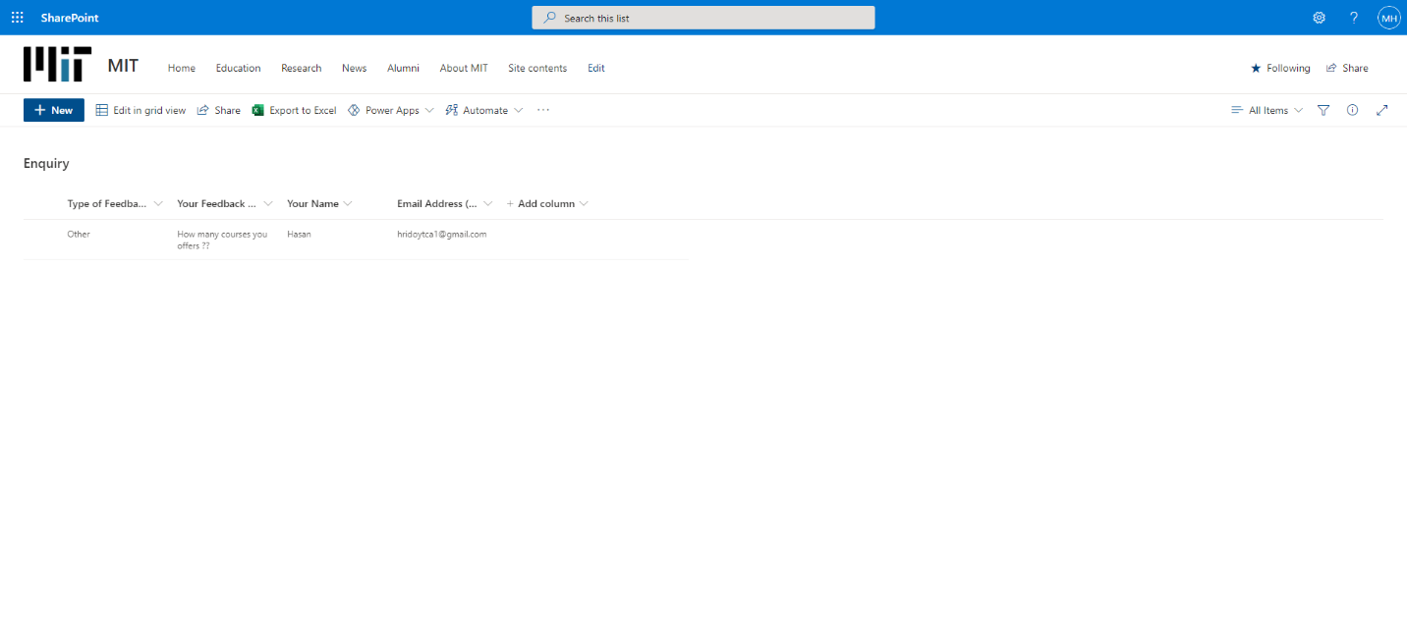

Screenshot 19: Data entered successfully in database

### **Work Flow**

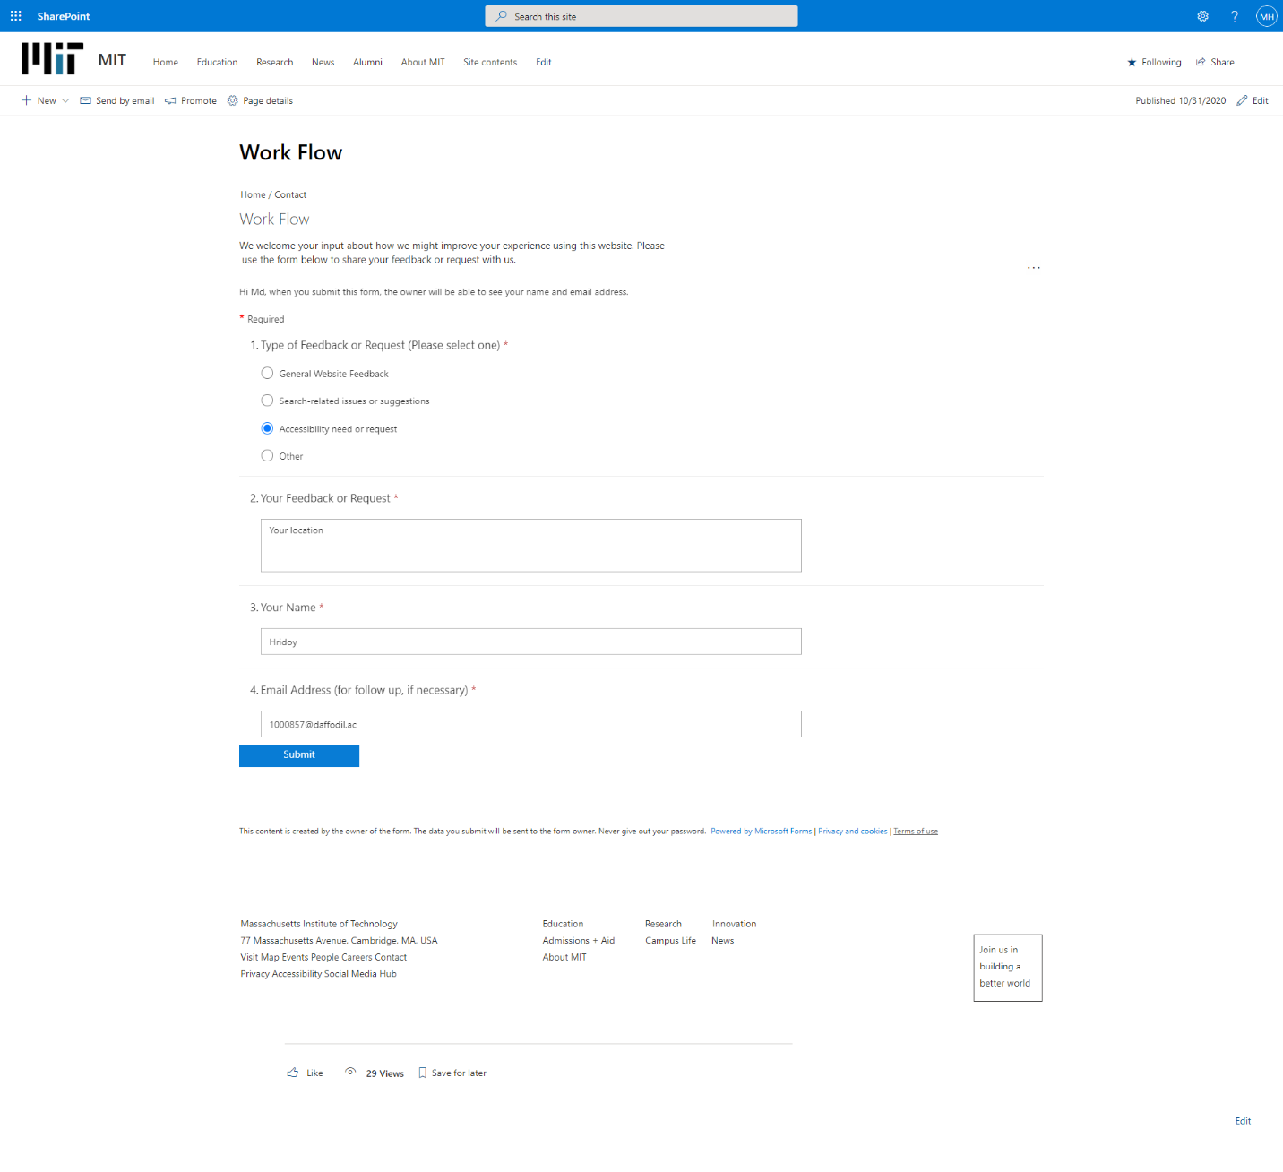

Screenshot 20: Entries for Work flow

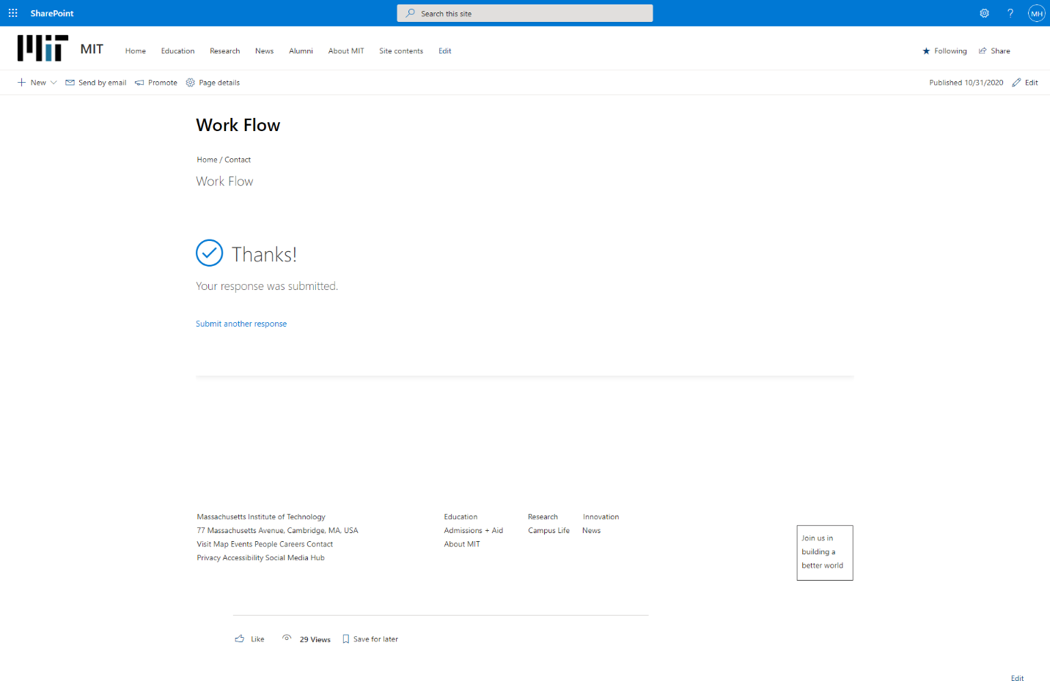

Screenshot 21: Data entered Successfully for workflow

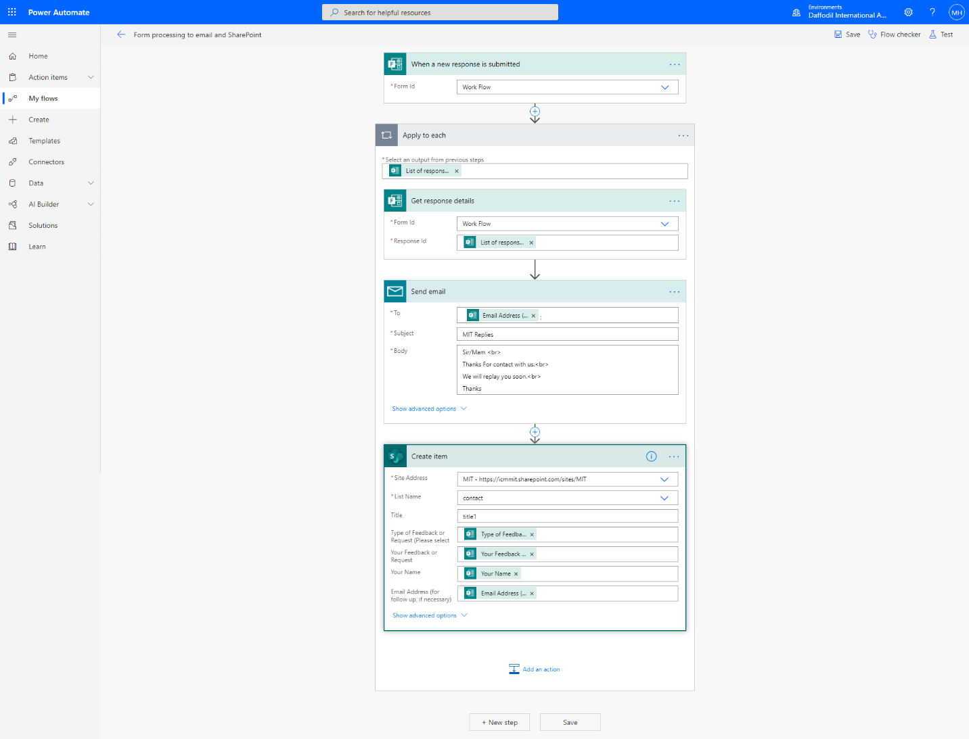

Screenshot 22: Full Process of working the workflow



Screenshot 23: Workflow is working successfully

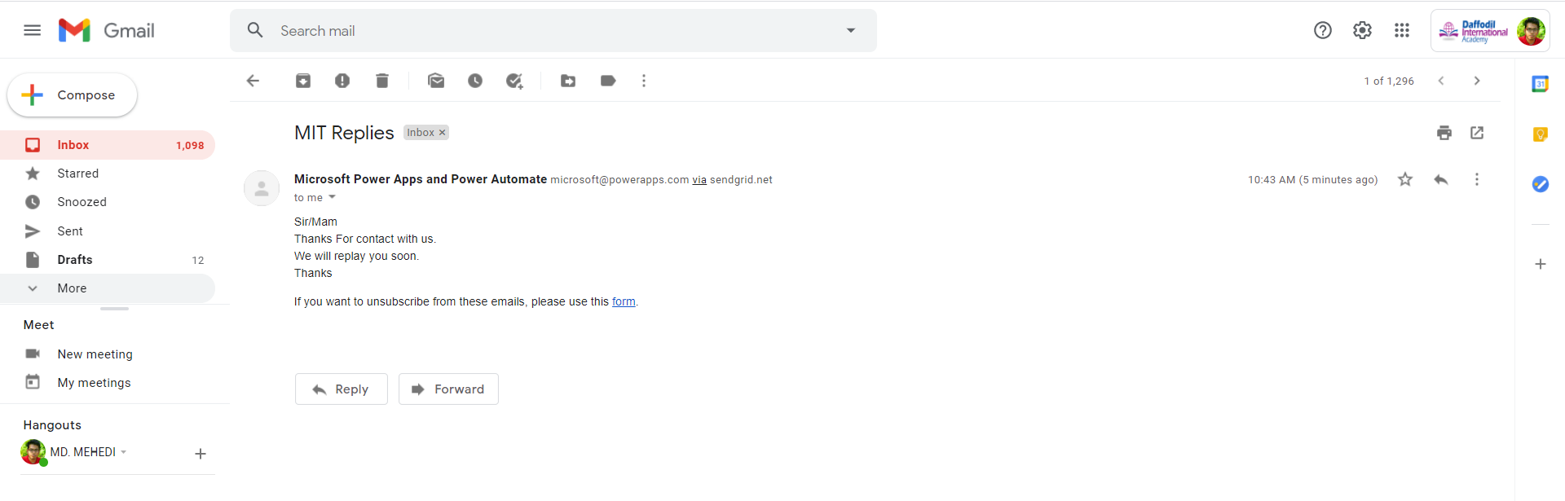

Screenshot 24: Email sent successfully

### **Under Development**

Some pages are in under development process.

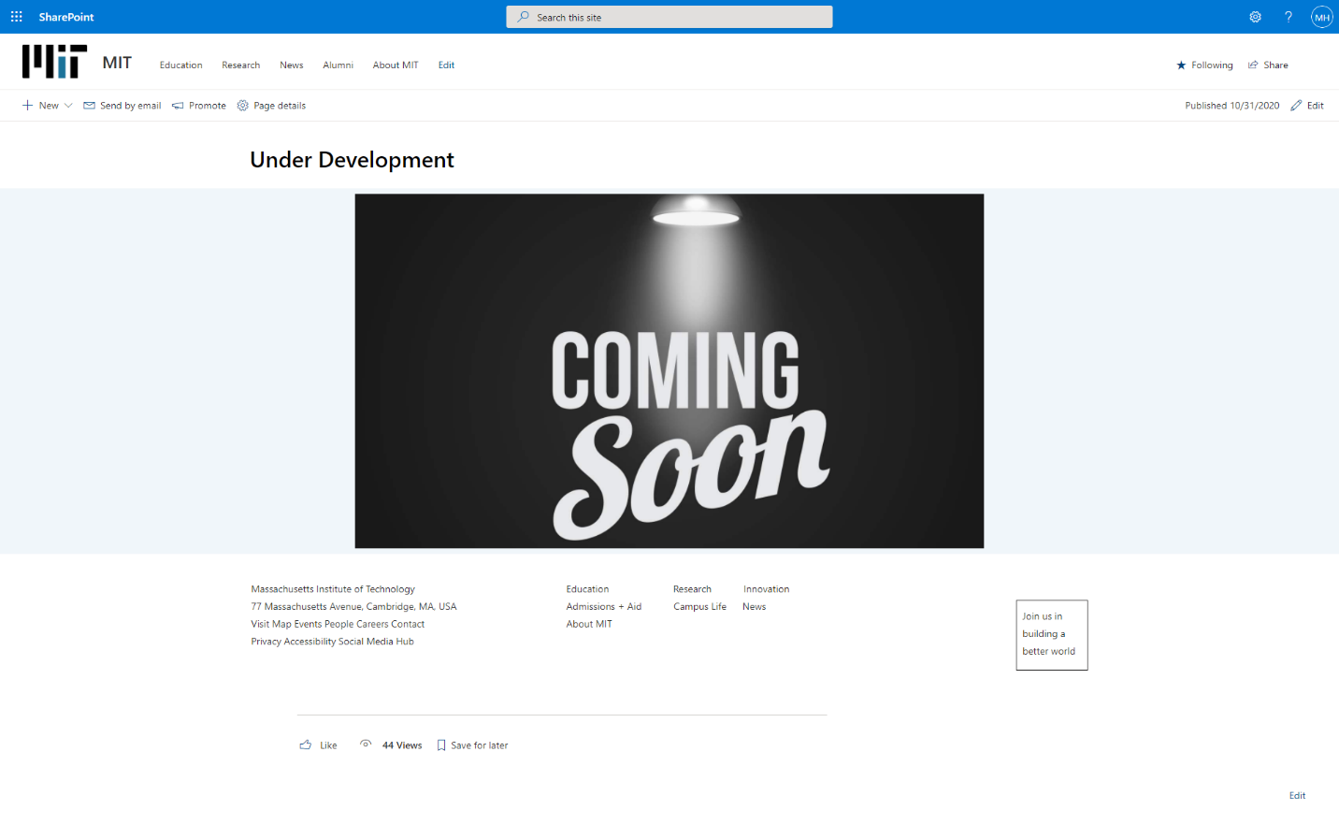

Screenshot 25: Under Development Page